Problem-Based Task: Interpretation of Data from Moodle and the BDP Tool

Participants are provided with concrete analyses from Moodle and the BDP learning design tool. They are required to review and interpret these analyses in written form, applying the guidelines studied. The interpretations must be submitted in Word or PDF format (the expected length is approximately 3 standard pages, with one page defined as 1,800 characters including spaces).

Part 1. Moodle

Below are examples of Moodle analyses related to a project management course delivered at the graduate level. The following are presented: (1) quiz statistics, (2) examples of learning material usage statistics, and (3) student activity throughout the semester.

  - Interpret and compare the statistics of the two quizzes conducted as part of the course. Propose the necessary improvements.

Exam 1

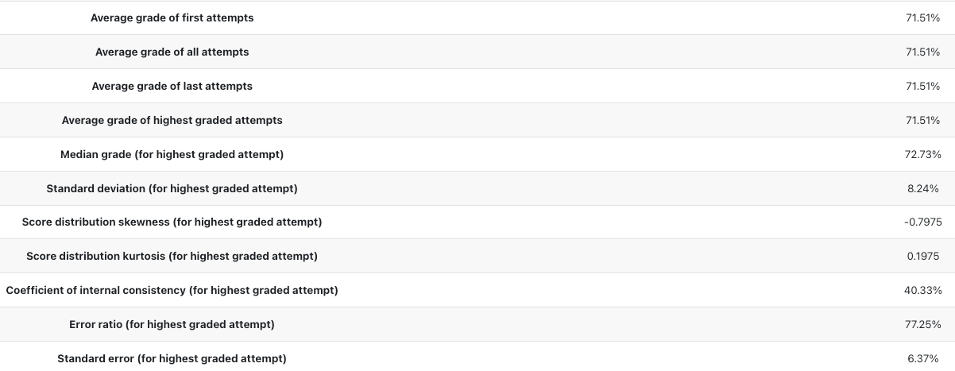

Exam 2

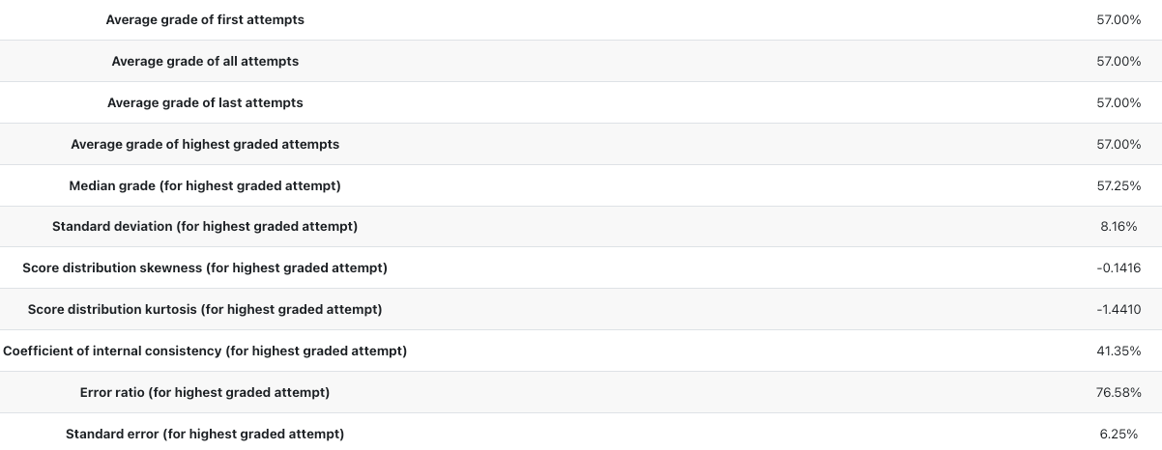

  - Interpret the examples of learning material usage statistics. Propose the necessary improvements.

Introduction to projects

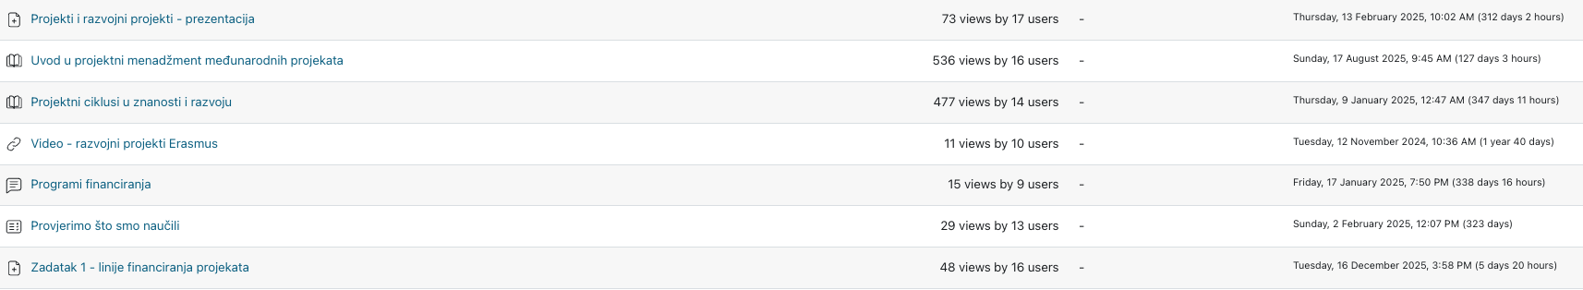

Dissemination

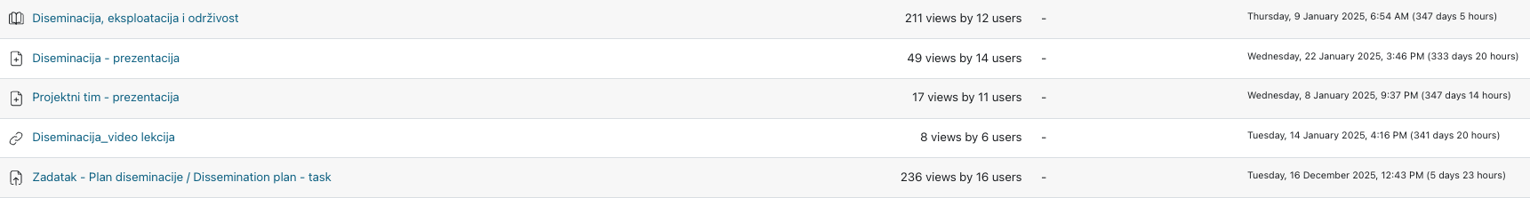

  - Based on the graph, examine and attempt to explain the pattern of student activity throughout the semester.
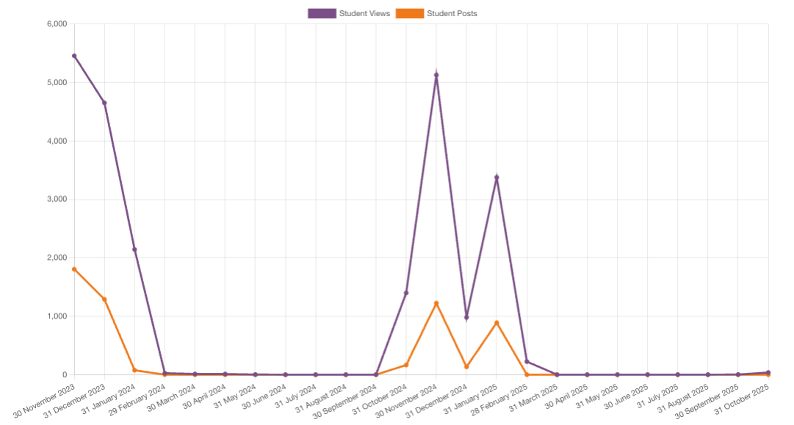

Part 2. BDP tool

2.1. Review the learning design analyses for the same course related to student workload and group work. What can you conclude from them?

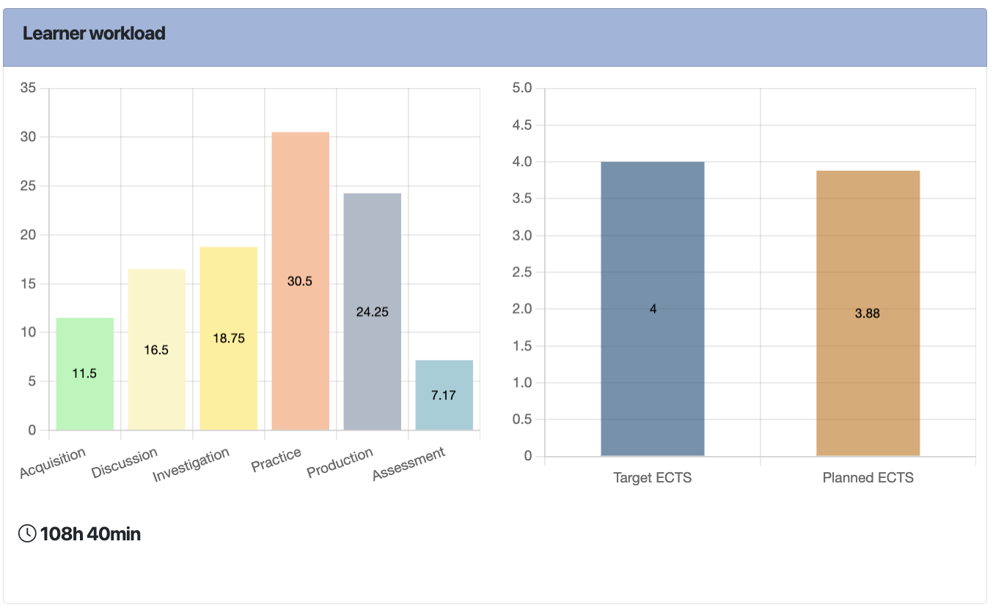
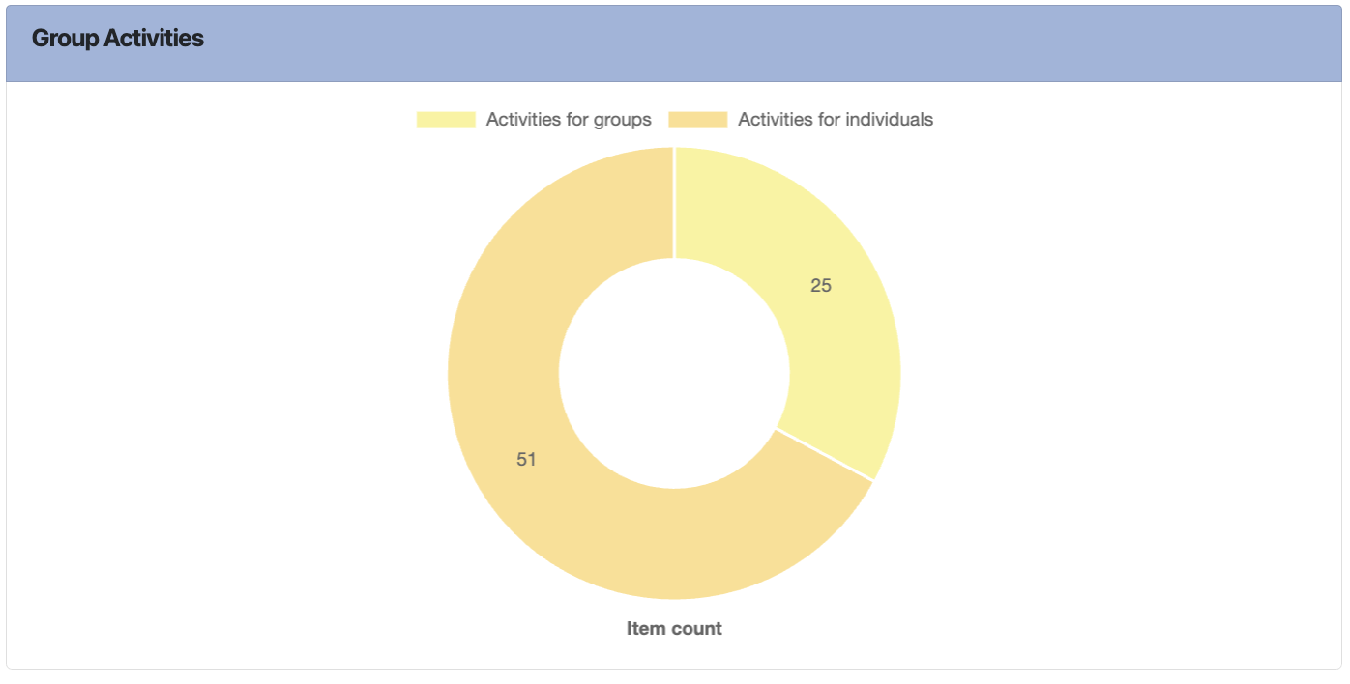

2.2. Interpret the student activity throughout the semester from the previous task in the context of the workload and group activity analyses.

